**Laboratory Practice II**

**Cloud Computing (A-3)**

**Problem Statement:- Creating an Application in SalesForce.com using Apex programming Language.**

**Apex :-**

Apex is a strongly typed, object-oriented programming language that allows developers to execute flow and transaction control statements on the Salesforce platform.

Steps :-

1) Create an account on <https://developer.salesforce.com>

2) Reset the New Password and confirm password

1. Create an Apex Class
2. Add a method to the class
3. Invoke and Test the code
4. Verify the Updated Accounts
5. **Create an account on** [**https://developer.salesforce.com**](https://developer.salesforce.com)

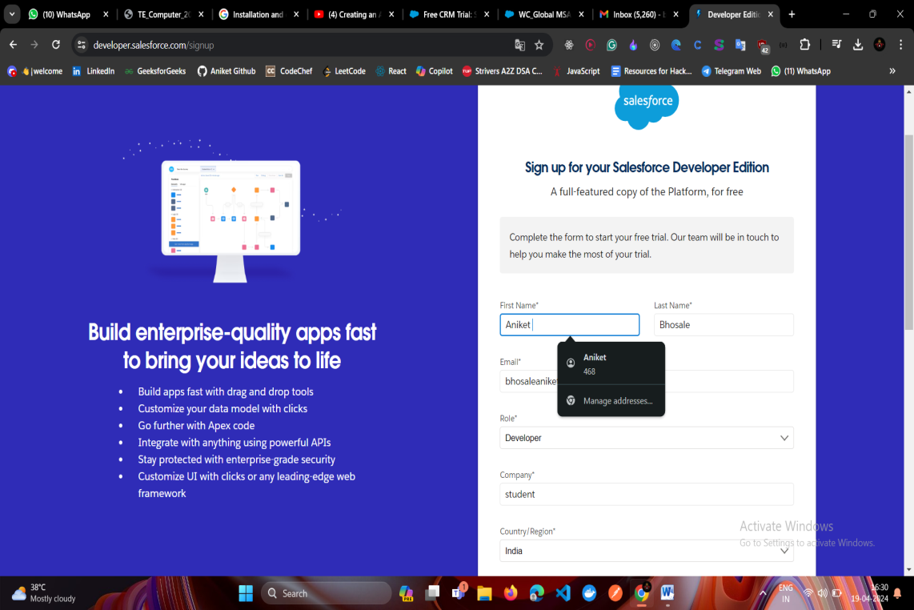

1. **Reset the Password and confirm password**

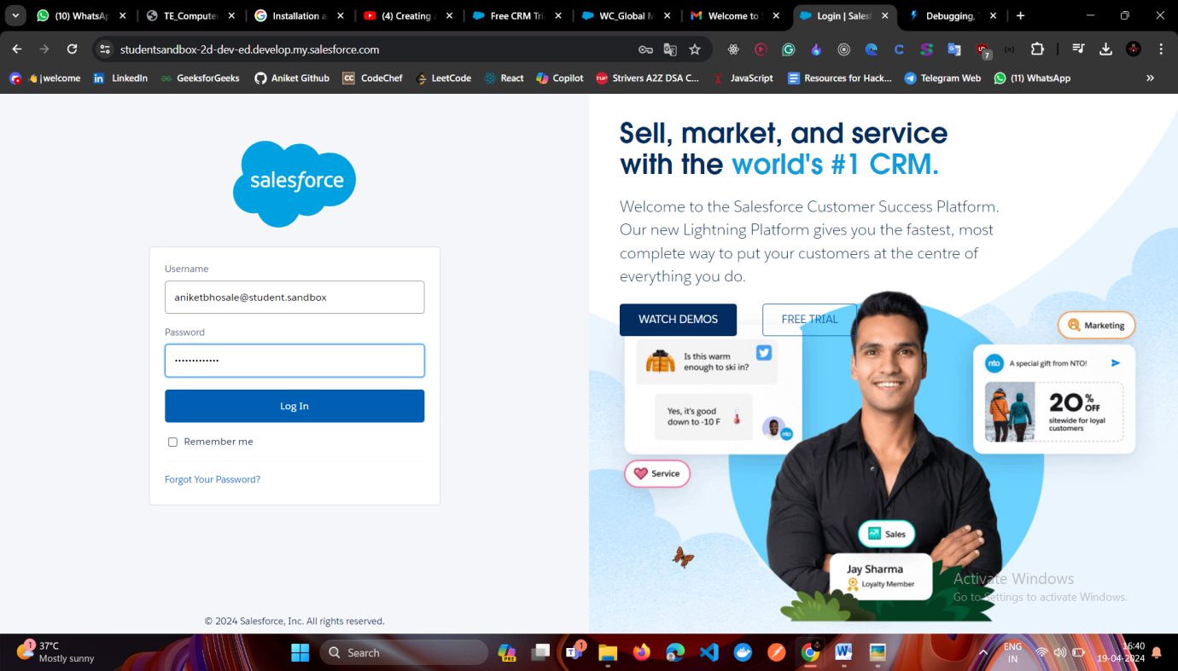

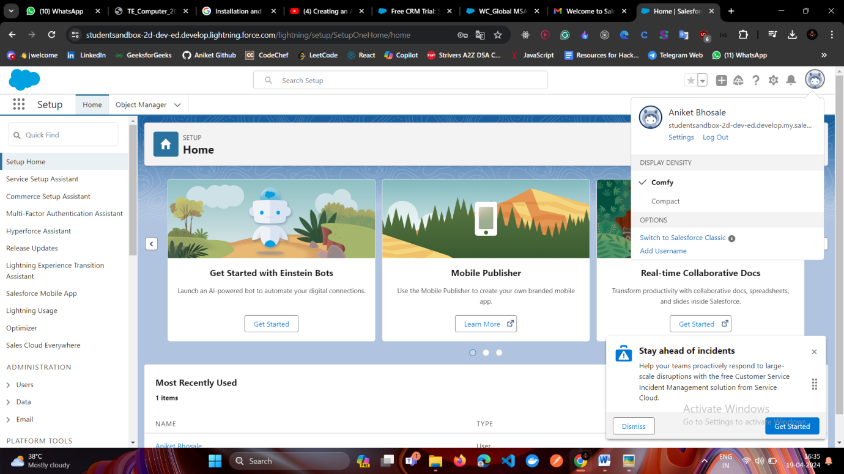

**3) Create an Apex Class**

The first step is to create an Apex class.

1. If you haven’t already, log in to Trailhead, then launch your Trailhead Playground by clicking Launch at the bottom of this page. This opens your Trailhead Playground in a new tab.

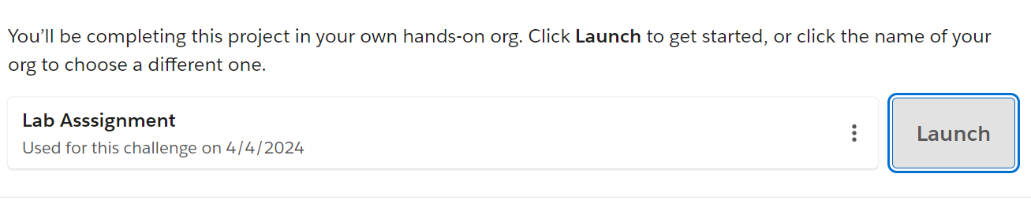

1. Click the setup gear Gear icon and select Developer Console.

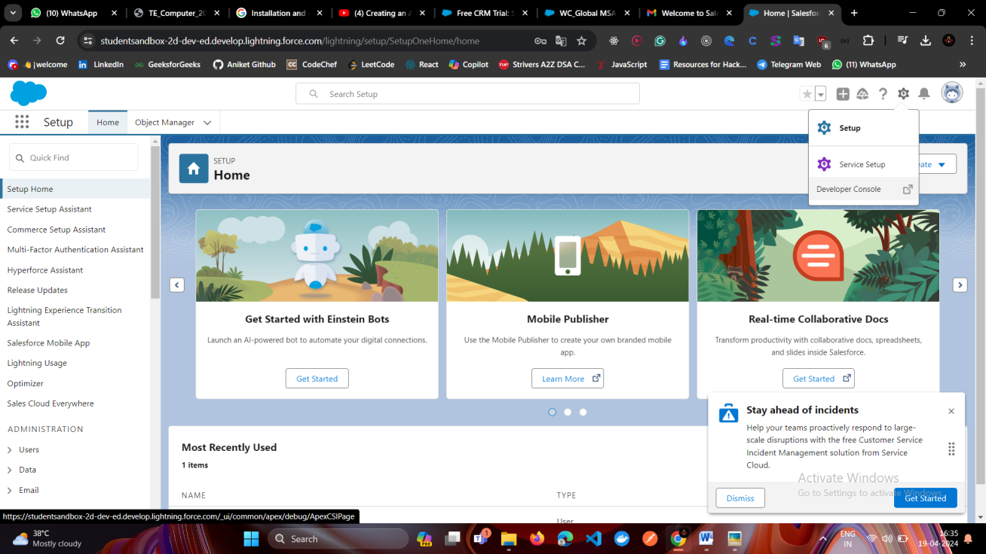

1. From the File menu, select New | Apex Class.

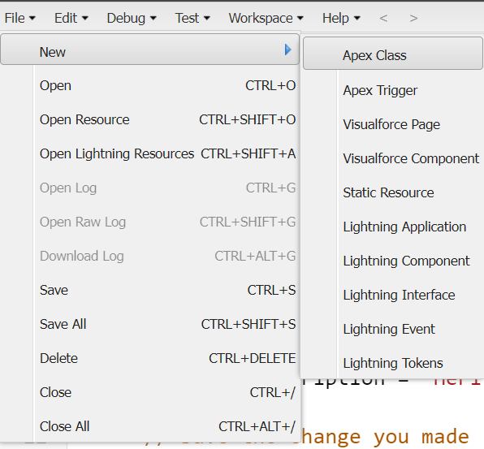

1. For the class name, enter classname and then click OK.

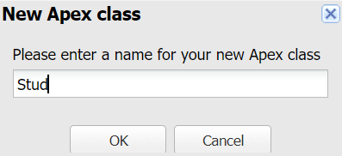

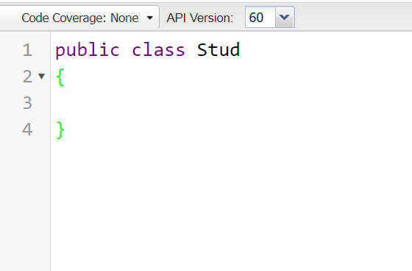

1. **Add a method to the class**

Create a Method

A class usually contains one or more methods that do something useful.

Method name :- LinearSearch

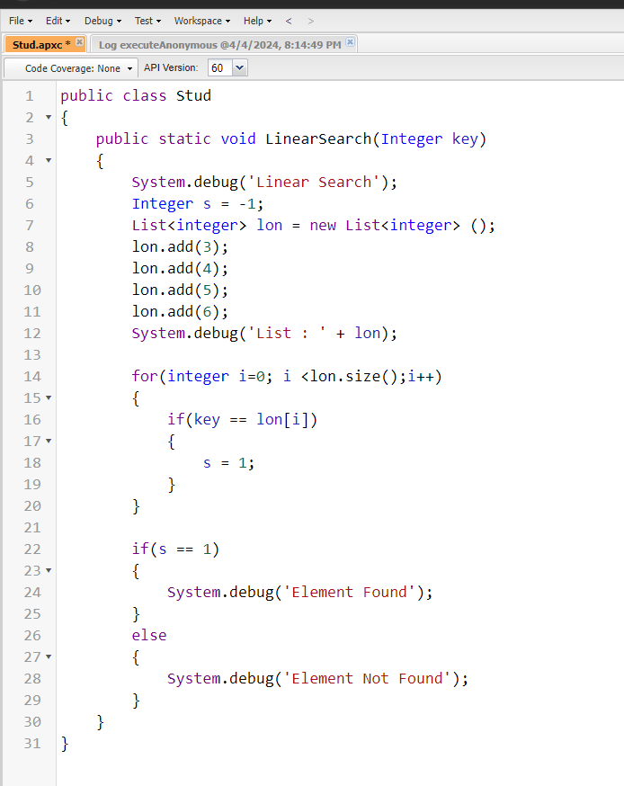

public class LinearSearch {

// Function to perform linear search

public static Integer linearSearch(Integer[] arr, Integer target) {

// Loop through each element of the array

for(Integer i = 0; i < arr.size(); i++) {

// If the current element matches the target, return its index

if(arr[i] == target) {

return i;

}

}

// If target is not found, return -1

return -1;

}

// Example usage

public static void main(String[] args) {

Integer[] arr = new Integer[]{10, 20, 30, 40, 50};

Integer target = 30;

Integer result = linearSearch(arr, target);

if(result != -1) {

System.debug('Element found at index: ' + result);

} else {

System.debug('Element not found');

}

}

}

1. **Invoke and Test the code**

